REFLECTION ON AreaProgram
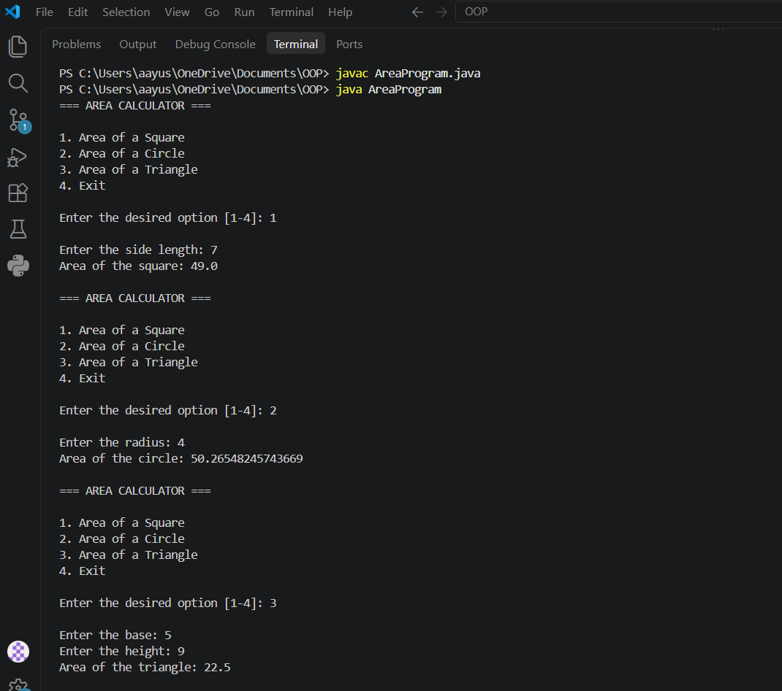
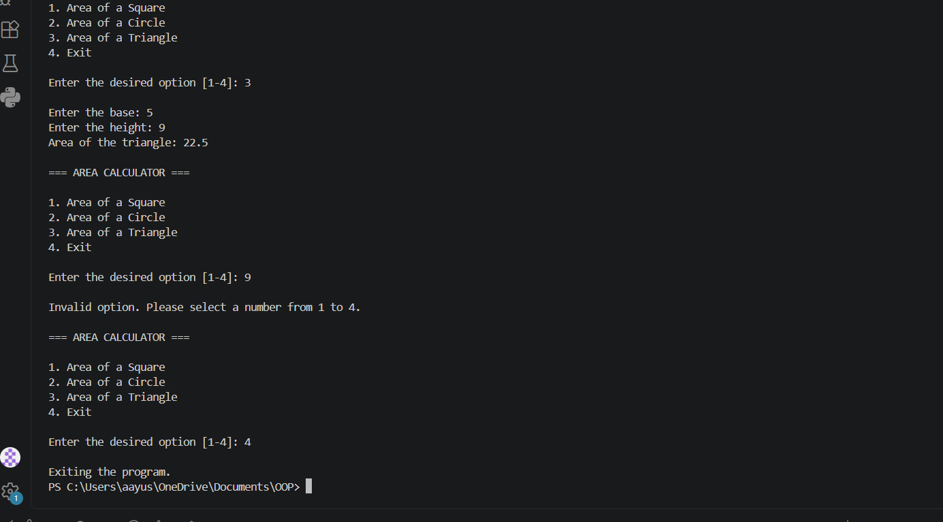
To complete the original AreaProgram.java, I kept the Scanner, option variable, and do-while loop from the given starter code. Then, I updated the menu, so it displayed all choices, 4 of them, and added a switch statement that responds to the option entered by the user. For each one, I added prompts to collect the necessary measurements. The square asks for side length, the circle asks for radius, and the triangle asks for a base and height. I created separate methods to calculate area of each figure. Added a default case to display error message if the user enters invalid option. The menu appears until the user enters 4.
I made several changes to follow the Google Java Style Guide. First, I used two spaces at the beginning of each nested line instead of tabs. Second, I placed opening braces for each line and added proper spacing around operators. I also used descriptive lowerCamelCase, loke sideLength, squareArea, calculateSquareArea. I stored the menu options as constants, using UPPER_SNAKE_CASE names, such as SQUARE_OPTION and EXIT_OPTION.
For the documentation, I addes Javadic above the class, main method, menu method, and calculations methods. The calculation methods include param tags that explain the input values and return tags that explain what each method returns. Javadoc begins with /** and is used to describe classes and methods. Also, can be used to generate html documentation. The change from // to /** made the program easier to read and understand. Using separate methods also improves the code because each calculation can be tested or if needed changed without affecting the rest of the program.

- I have attached the github link for my code.
https://github.com/aayusha2042/CS-3354-Exercise/blob/main/AreaProgram.java

